**Assignment-1**

|  |  |
| --- | --- |
| Date | 10 September 2022 |
| Team ID | PNT2022TMID31899 |
| Student Register Number | 721219106055 |
| Maximum Marks | 2 Marks |

**Question-1:**

**Make a Common Circuit in tinkercad using PIR sensor ,Buzzer and LED. Motion detect by sensor and make alarm.**

**Solution:**

void setup()  
 {  
  pinMode(LED_BUILTIN, OUTPUT);  
 }  
  
 void loop()  
 {  
  digitalWrite(LED_BUILTIN, HIGH);  
  delay(1000); // Wait for 1000 millisecond(s)  
  digitalWrite(LED_BUILTIN, LOW);  
  delay(1000); // Wait for 1000 millisecond(s)  
 }

**Circuit Diagram:**

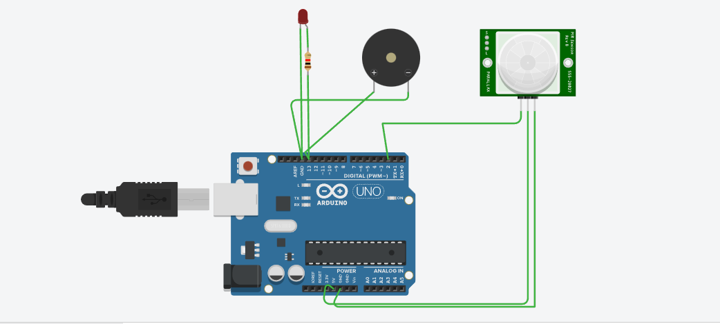

**Components:**

|  |  |  |  |
| --- | --- | --- | --- |
| S.No | Name | Quantity | Component |
| 1. | U1 | 1 | Arduino Uno R3 |
| 2. | PIEZO1 | 1 | Piezo |
| 3. | PIR1 | 1 | PIR Sensor |
| 4. | R1 | 1 | Resistor |
| 5. | D1 | 1 | Red LED |